Experiment No.: 10 Date:

Title: To design a Firewall using Standard and Extended ACL’s
Learning Objectives: At the end of this experiment, students will be able to:
- Filter packets using Standard ACL’s
- Filter packets using Extended ACL’s
Pre-requisite: Basic concepts of IP addressing, ICMP, TCP, Application layer protocols such as HTTP, FTP, Telnet
Apparatus: Cisco Packet Tracer
Theory:

Firewall
Firewalls are an excellent security mechanism to protect networks from intruders, and they can establish a relatively secure barrier between a system and the external environment.
firewall for an organization's needs requires careful consideration of the available types and products.
Packet Filters
The most basic type of firewall is a packet filter. It receives packets and evaluates them according to a set of rules that are usually in the form of ACL’s (access control lists). ACLs are basically a set of commands, grouped together by a number that is used to filter traffic entering or leaving an interface. After applying ACL’s, packets may be forwarded to their destinations, dropped, or dropped with a return message to the originator describing what happened. Most frequently used packet filtering rules are based on:
- Source and destination IP address
- Source and destination port
- Direction of traffic (e.g., inbound or outbound).
- Type of protocol (e.g., IP, TCP, user datagram protocol, or internetwork packet
exchange).
Types of ACLs
Each of these references to ACLs supports two types of filtering: standard and extended.
- Standard ACLs :- A standard ACL is simple; it filters based on source address only. We can filter a source network or a source host, but we cannot filter based on the destination of a packet, the particular protocol being used such as the Transmission Control Protocol (TCP) or the User Datagram Protocol (UDP), or on the port number. We can permit or deny only source traffic.
Standard ACLs format
access-list access-list-number {deny | permit} source address
- Extended ACL:
An extended ACL gives us much more power than just a standard ACL. Extended IP ACLs check both the source and destination packet addresses. They can also check for specific protocols, port numbers, and other parameters, which allow administrators more flexibility and control.

Extended ACL format:
access-list access-list-number {deny | permit} protocol source source-wildcard destination destination-wildcard port no.
- Access List Ranges
Type | Range
IP Standard | 1–99
IP Extended | 100–199
IP Standard Expanded Range | 1300–1999
IP Extended Expanded Range | 2000–2699
- Wildcards

Wildcards are used with access lists to specify an individual host, a network, or a certain range of a network or networks.
Formula to calculate wild card mask for access list
Wildcard mask = 255.255.255.255 – subnet mask
When activating an ACL on an interface, we have to specify in which direction the traffic should be filtered:
- In ACL (as the traffic comes into an interface)
- Out ACL(before the traffic exits an interface)
In ACL :- Traffic that arrived on the interface on which the ACL is applied on and then if permitted goes through the router.
Out ACL :- Traffic that has been through the router and is leaving the interface on which the ACL is applied on and then if permitted goes through the router.
Steps followed:
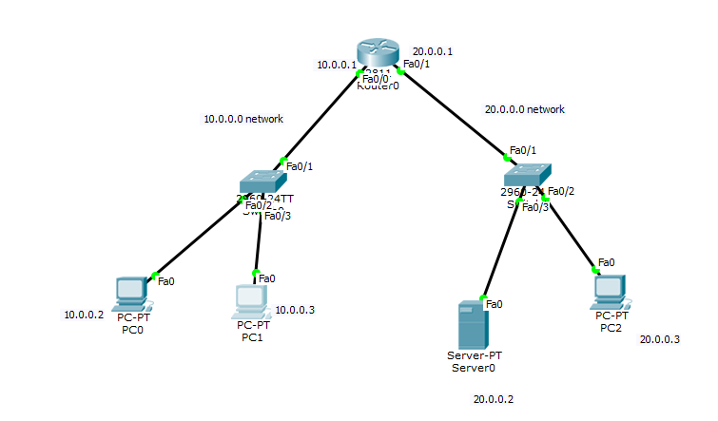
- Configure the network as shown in figure.
- Write access lists (ACLs) in configuration mode.
- Apply ACLs on the particular port of the router in a specific direction.
- Remove previous ACL before applying the new ACL.
- Check and verify the result of each ACL.
Task 1(Standard access-lists)
Our task is to give access to 10.0.0.2 from gaining access on 20.0.0.0 network. Other computer from the network of 10.0.0.0 must not be able to connect with the network of 20.0.0.0.
Code to configure the router for task 1:

Result :
- Ping 20.0.0.2 (from 10.0.0.2)
- Ping 10.0.0.3(from 10.0.0.2)
- Ping 20.0.0.3 (from 10.0.0.3)

Task 2(Standard access list)
Our task is to block 10.0.0.2 from gaining access on 20.0.0.0. Other computer from the network of 10.0.0.0 must be able to connect with the network of 20.0.0.0.
Code to configure the router for task 2:

Result:
- Ping 20.0.0.2 (from 10.0.0.2)
- Ping 10.0.0.3(from 10.0.0.2)
- Ping 20.0.0.3 (from 10.0.0.3)

Task 3 (Extended ACL)
Our task is to allow HTTP access (server is 20.0.0.2)to 10.0.0.2 .all other hosts must not be able to communicate with web server 20.0.0.2.

Code to configure the router for task 3:
Result:
- On web browser of 10.0.0.2 type 20.0.0.2
- On web browser of 10.0.0.3 type 20.0.0.2

Task 4 (Extended ACL)
Our task is to deny FTP access (server is 20.0.0.2) to 10.0.0.2. all other hosts must be able to communicate with ftp server 20.0.0.2.

Code to configure the router for task 4:
Result:
- From command prompt of 10.0.0.3 type ftp 20.0.0.2
- From command prompt of 10.0.0.2 type ftp 20.0.0.2

Task 5 (Extended ACL)
Our task is to deny SMTP access (server is 20.0.0.2) to 10.0.0.2. all other hosts must be able to communicate with smtp server 20.0.0.2.

Code to configure the router for task 5:
Result:
- From Email option of PC 10.0.0.2 configure E-mail account and try to send emails
- From Email option of PC 10.0.0.3 configure E-mail account and try to send emails

